Ghana

## Political Stability Estimate Data

The data set shows the political stability estimate of the country each year.

## # A tibble: 19 x 5  
## country iso3c date stability stabilityCategory4   
## <chr> <chr> <dbl> <dbl> <chr>   
## 1 Ghana GHA 1996 -0.233 moderately unstable  
## 2 Ghana GHA 1998 -0.135 moderately unstable  
## 3 Ghana GHA 2000 -0.360 moderately unstable  
## 4 Ghana GHA 2002 -0.164 moderately unstable  
## 5 Ghana GHA 2003 0.0288 moderately stable   
## 6 Ghana GHA 2004 0.0400 moderately stable   
## 7 Ghana GHA 2005 0.168 moderately stable   
## 8 Ghana GHA 2006 0.00803 moderately stable   
## 9 Ghana GHA 2007 -0.0718 moderately unstable  
## 10 Ghana GHA 2008 -0.0276 moderately unstable  
## 11 Ghana GHA 2009 0.0299 moderately stable   
## 12 Ghana GHA 2010 0.0261 moderately stable   
## 13 Ghana GHA 2011 0.167 moderately stable   
## 14 Ghana GHA 2012 0.131 moderately stable   
## 15 Ghana GHA 2013 0.0606 moderately stable   
## 16 Ghana GHA 2014 -0.107 moderately unstable  
## 17 Ghana GHA 2015 -0.0321 moderately unstable  
## 18 Ghana GHA 2016 -0.131 moderately unstable  
## 19 Ghana GHA 2017 0.0865 moderately stable

## Political Stability Estimate Plot

The plot shows the trends of stabilization and destabilization for the each country.

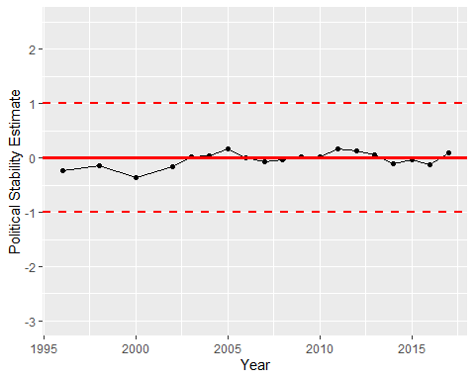

Political Stability Trend